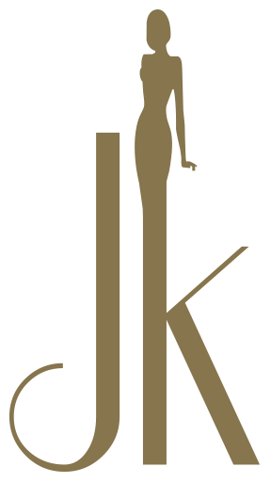

COVID-19 Pandemic Skin/ Body Treatment Consent Form

Please take a moment to complete our consent form.
By submitting the form below you agree to knowingly and willingly consenting to have skin/body treatments during the COVID-19 pandemic.

We reserve the right to refuse service if this form is not submitted. Thank you.

First Name Last Name

I understand the COVID-19 virus has a long incubation period during which carriers of the virus may not show symptoms and still be highly contagious. It is impossible to determine who has it and who does not, given the current limits in virus testing. *

Yes

I understand that due to the frequency of visits of other clients, the characteristics of the virus, and the characteristics of skin treatments, that I have an elevated risk of contracting the virus simply by being in the clinic. *

Yes

I confirm that I am not presenting any of the following symptoms of COVOID-19 listed below: *

• Temperature above 98.7 degrees
• Shortness of breath
• Loss of sense of taste or smell
• Dry cough • Sore Throat

I Am Not Presenting Symptoms

I confirm that I have not been around anyone with these symptoms in the past 14 days. *

Yes

I do not live with anyone who is sick or quarantined. *

I Do Not

To prevent the spread of contagious viruses and to help protect each other, I understand that I will have to follow the salon’s strict guidelines. *

Yes

To prevent the spread of contagious viruses and to help protect each other, I understand that I will have to follow JK Skin Aesthetics rules and strict guidelines. (Please Read the Above Policy)*

Yes

Please enter today's date.
Date *

DD
MM
YYYY

Please sign your full name below. By signing this consent form this verifies that you fully agree to our safety policy for our services. Thank you.

Signature *

